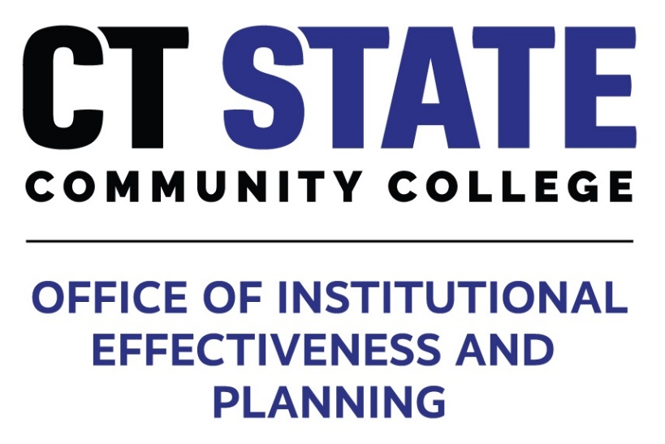

**2024-25 Academic Program Review**

**Timeline and Self-Study Template**

Updated October 31, 2024

CT State Academic Program Review Timeline for Academic Years 24-25

|  |  |  |
| --- | --- | --- |
| Activities | Time Period | Deliverables |
| Director of Academic Program Review and Assessment notifies COS Academic Deans, Campus Deans, Department Chairs, Program Coordinators, and other key stakeholders of programs that are due for Academic Program Review (APR) in the 2024-25 academic year. | October  2024 | Notification email to all key stakeholders. |
| College of Study Deans work collaboratively with Campus Deans, Department Chairs, and Program Coordinators to establish roles and responsibilities for completing the APR Self-Study report. APR Self-Study Teams should include the Campus Dean, appropriate Department Chair, Program Coordinator, and members of the program faculty. | November  2024 | APR Self-Study Teams are established and notification is sent to the Director of Program & Assessment. |
| The Self-Study Team identifies and requests necessary data and/or technical assistance from the Office of Institutional Effectiveness and Planning (IE&P); designs student and staff surveys and other data collection tools, if appropriate; and identifies a preliminary list of individuals willing to serve as external reviewers. | | December 2024 | * Request for data and/or technical assistance from the Offices of IE&P * Student and/or staff surveys and/or other data collection tools, if appropriate * List of potential external reviewers |
| The Self-Study Team (with IE&P support) meets to review information, including:: 1) data on enrollment, student success, learning outcomes, instructional methods & modalities, staffing, and current & projected employment trends for program graduates; 2) syllabi and CVs from full and part-time faculty and professional staff; and, if appropriate, 3) the results of student and staff surveys and other data collection tools, if any. Requests for additional information and/or technical assistance, if any, are sent to the Director of Program Review and Assessment. | | January-March 2025 | * Analyses of data from IE&P * Syllabi and CVs from full and part-time faculty and professional staff * Results of student/staff surveys and other data collection tools * Requests for additional information and/or technical assistance. |
| The Self-Study Team (with IE&P support) meets to 1) draw conclusions from data; 2) discuss future priorities for curriculum, staffing, budgeting, facilities, equipment, technology, and other resources; 3) divide the work of report writing. | March-April  2025 | * Conclusions from data sources * List of future priorities for curriculum, staffing, budgeting, facilities, equipment, technology, and other resources * Assignments and deadlines for report writing |
| The Self-Study Team meets to review progress on sections I and II of the APR self-study report and address additional needs for information or technical assistance (if any) prior to the end of AY 2024-25. | | May 2025 | Updates and requests for additional information and/or technical assistance are sent to the Director of Program Review and Assessment. |
| The Self-Study Team (with IE&P support) completes sections I and II of the APR Self Study Report and submits them to the Director of Program Review and Assessment. | | September-October 2025 | Sections I and II of the Self-Study Report |
| The Self-Study Team incorporates feedback from external reviewers and completes section III-V. | | October – November 2025 | Sections I-V of Self-Study Report, including reviewer comments and appendices. |
| Self-Study Teams submit self-study reports sections I-V to the Director of Program Review and Assessment who will provide copies to Campus Deans, COS Academic Deans, CEOs, and Provost for review. | December 2025 | NA |
| The CT State Leadership Team reviews self-study reports from the previous academic year. | January-February 2026 | NA |
| Self-Study Teams present their reports during meetings of the President’s cabinet. Written and oral feedback from the Leadership Team is subsequently presented to Self-Study Teams. | March-April 2026 | * Presentation at President’s Cabinet meeting. * Written administrative response to the self-study report. |
| Self-Study Teams prepare final versions of their self-study reports including section VI and all appendices. | May 2026 | Final self-study report. |
| Final self-study reports are submitted to the CSCU system office and made available for review by the BOR Academic and Student Affairs Committee. The BOR accepts the reports and action plans and responds by confirming the strategic directions of the programs. | June 2026 | TBD |

|  |
| --- |
| **Appendix B: CT State Academic Program Review (APR) Self-Study Template**  **Provided by the Office of Institutional Effectiveness & Planning (IE&P)**  **Department of Program Review & Assessment (DOPRA)**  **General Guidelines:**  Non-externally accredited, credit-bearing, degree and certificate programs are expected to submit a self-study report that includes all sections contained in this template. Externally accredited programs may submit their accreditation self-study reports in lieu of the APR self-study report. |

**Section I: Overview of the Program**

1. **Name of Program:**

|  |
| --- |
|  |

1. **Program Coordinator(s):**

|  |
| --- |
|  |

1. **Department Chair(s):**

|  |
| --- |
|  |

1. **Campus(es) Where Program is Offered:**

|  |
| --- |
|  |

1. **Program Description:**

|  |
| --- |
|  |

1. **Program Mission and Goals:**

|  |
| --- |
|  |

1. **Curriculum Description (See Appendix A for syllabi for all required courses):**

|  |
| --- |
|  |

1. **List of Essential Student Learning Outcomes (SLOs):**

|  |
| --- |
|  |

1. Curriculum map – See Appendix B.
2. Instructional modalities –See Appendix C for system approved data forms showing, by semester, the number of sections and enrollment figures for each modality for the previous five academic years.
3. **Description of Program Resources:**
4. Faculty and support staff (See Appendix D for the resumes and/or CVs of all full and part-time faculty and professional staff).

|  |
| --- |
|  |

1. Faculty and staff development and evaluation

|  |
| --- |
|  |

1. Physical resources

|  |
| --- |
|  |

1. Fiscal resources

|  |
| --- |
|  |

1. Enrollment trends – See Appendix C for System Approved Data Forms with tables, charts, and/or graphs showing enrollment trends for the previous five academic years.
2. Student characteristics See Appendix C for System Approved Data Forms with tables, charts, and/or graphs.

**Section II: Appraisal of the Program**

1. **Description of Current and Projected Employment Trends:**

|  |
| --- |
|  |

1. **Measures of Student Success:**

|  |
| --- |
|  |

1. **Results of Student Learning Outcome (SLO) Assessments:**

|  |
| --- |
|  |

**Section III: Feedback from External Reviewers and/or Advisory Groups**

**(May be included as Appendix E)**

|  |
| --- |
|  |

**Section IV: Discussion of Appraisal Results**

1. **Critique of program infrastructure and resources:**

|  |
| --- |
|  |

1. **Key conclusions:**

|  |
| --- |
|  |

1. **Key themes identified in the responses from external reviewers and/or advisory groups:**

|  |
| --- |
|  |

**Section V: Executive Summary and Action Plan**

1. **Synopsis of program strengths and challenges:**

|  |
| --- |
|  |

1. **Description of how assessment and program data will be used for continuous improvement:**

|  |
| --- |
|  |

1. **Program improvement plan:**

|  |
| --- |
|  |

**Section VI: Response from Campus and CT State Leadership**

**(May be included as Appendix F)**

|  |
| --- |
|  |

**Required Appendices**

Appendix A: Syllabi for all required courses and BOR forms or documents

Appendix B: Curriculum map

Appendix C: System approved data forms

Appendix D: Faculty and staff resume/CVs

Appendix E: Reviewer comments if not included in Section III.

Appendix F: Written response to the self-study report from CT State Leadership if not included in Section VI

**Optional Appendices**

Appendix G: Faculty and staff development artifacts

Appendix H: Examples of assessment tools such as model or common assignments, rubrics, or surveys

**Signatures of Self-Study Team:**

Self-Study Team Chair ______________________________________ Date ______________

Self-Study Team Member ______________________________________ Date ______________

Self-Study Team Member ______________________________________ Date ______________

Self-Study Team Member ______________________________________ Date ______________

T**he following signatures acknowledge receipt of this report:**

Director of Program Review & Assessment ______________________________________ Date ______________

College of Study Academic Dean ______________________________________ Date ______________

CT State Provost ______________________________________ Date ______________